# Reproducible Research Project 1

### *Loading and preprocessing the data*

unzip(zipfile="activity.zip")

data <- read.csv("activity.csv")

## *What is total number of steps taken each day?*

library(ggplot2)

total.steps <- tapply(data$steps, data$date, FUN=sum, na.rm=TRUE)

qplot(total.steps, binwidth=1000, xlab="total number of steps taken each day")

[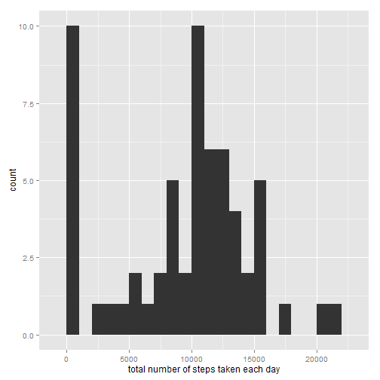](https://github.com/UtkarshPathrabe/Reproducible-Research-Johns-Hopkins-Bloomberg-School-of-Public-Health-Coursera/blob/master/Project%2001/figure/unnamed-chunk-1-1.png)

## *What is the mean and median number of steps taken each day?*

mean(total.steps, na.rm=TRUE)

## [1] 9354.23

median(total.steps, na.rm=TRUE)

## [1] 10395

## *What is the average number of steps taken?*

library(ggplot2)

averages <- aggregate(x=list(steps=data$steps), by=list(interval=data$interval),

FUN=mean, na.rm=TRUE)

ggplot(data=averages, aes(x=interval, y=steps)) +

geom_line() +

xlab("5-minute interval") +

ylab("average number of steps taken")

[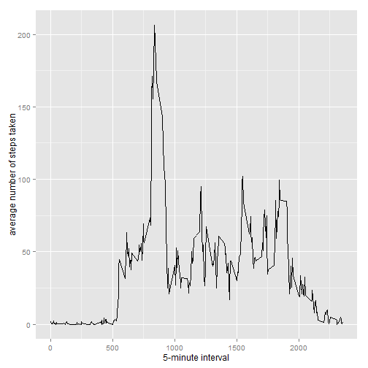](https://github.com/UtkarshPathrabe/Reproducible-Research-Johns-Hopkins-Bloomberg-School-of-Public-Health-Coursera/blob/master/Project%2001/figure/unnamed-chunk-2-1.png)

## *The 5-minute interval that, on average, contains the maximum number of steps?*

averages[which.max(averages$steps),]

## interval steps

## 104 835 206.1698

## *Inputting missing data values strategy*

There are days and intervals where there are missing values (coded as NA). The presence of missing days may introduce bias into some calculations or summaries of the data and needs to be remedied.

missing <- is.na(data$steps)

# How many missing

table(missing)

## missing

## FALSE TRUE

## 15264 2304

Missing values are filled in with mean value for that 5-minute interval.

# Replace each missing value with the mean value of its 5-minute interval

fill.value <- function(steps, interval) {

filled <- NA

if (!is.na(steps))

filled <- c(steps)

else

filled <- (averages[averages$interval==interval, "steps"])

return(filled)

}

filled.data <- data

filled.data$steps <- mapply(fill.value, filled.data$steps, filled.data$interval)

Using the filled data set, produce a histogram of the total number of steps taken each day and calculate the mean and median total number of steps.

total.steps <- tapply(filled.data$steps, filled.data$date, FUN=sum)

qplot(total.steps, binwidth=1000, xlab="total number of steps taken each day")

[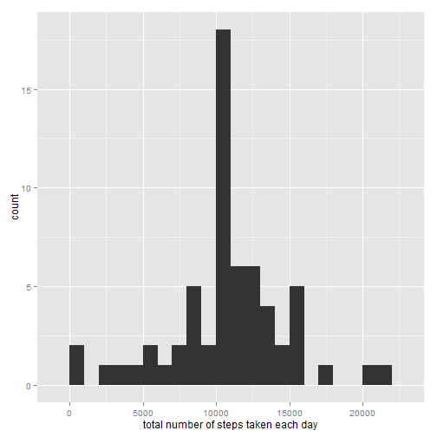](https://github.com/UtkarshPathrabe/Reproducible-Research-Johns-Hopkins-Bloomberg-School-of-Public-Health-Coursera/blob/master/Project%2001/figure/unnamed-chunk-5-1.png)

mean(total.steps)

## [1] 10766.19

median(total.steps)

## [1] 10766.19

Summary: The mean and median values are higher after inputting missing data. The reason is that in the original data, there are some days with steps values NA for any interval. The total numbers of steps taken in such days are set to 0s by default. However, after replacing missing steps values with the mean steps of associated interval value, these 0 values are removed from the histogram of total number of steps taken each day.

## *Differences in activity patterns between weekdays and weekends*

### Find the day of the week for each measurement in the dataset. In this part, we use the dataset with the filled-in values.

weekday.or.weekend <- function(date) {

day <- weekdays(date)

if (day %in% c("Monday", "Tuesday", "Wednesday", "Thursday", "Friday"))

return("weekday")

else if (day %in% c("Saturday", "Sunday"))

return("weekend")

else

stop("invalid date")

}

filled.data$date <- as.Date(filled.data$date)

filled.data$day <- sapply(filled.data$date, FUN=weekday.or.weekend)

## *Make a panel plot containing plots of average number of steps taken on weekdays and weekends.*

averages <- aggregate(steps ~ interval + day, data=filled.data, mean)

ggplot(averages, aes(interval, steps)) + geom_line() + facet_grid(day ~ .) +

xlab("5-minute interval") + ylab("Number of steps")

[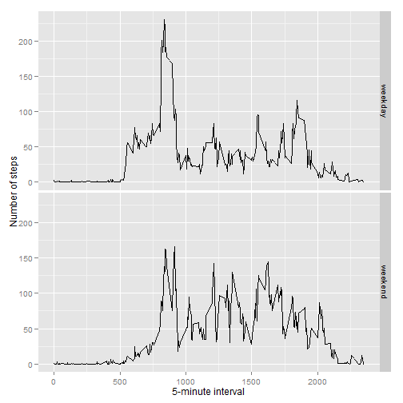](https://github.com/UtkarshPathrabe/Reproducible-Research-Johns-Hopkins-Bloomberg-School-of-Public-Health-Coursera/blob/master/Project%2001/figure/unnamed-chunk-7-1.png)